**Genealogical data in MANTO**

The following ties describe **blood relationships:**

ENTITY is parent / child / sibling / twin of ENTITY

ENTITY is divine father of ENTITY

ENTITY1 is mother by parthenogenesis of ENTITY2 (Reversal: ENTITY1 is mother of ENTITY2; NONE is father of ENTITY2)

ENTITY1 gives birth to ENTITY2 (Reversal: ENTITY1 is mother of ENTITY2)

We also have one tie which captures a relationship by blood that is not otherwise specified:

ENTITY is a descendant of ENTITY

You can probably just ignore this tie.

The following ties describe **relationships by marriage**:

ENTITY is spouse of ENTITY

ENTITY1 marries ENTITY2 (reversal: ENTITY1 is spouse of ENTITY2)

ENTITY1 gives in marriage ENTITY2 to ENTITY3 (reversal: ENTITY2 is spouse of ENTITY3

**Unusual births in MANTO (depict using icons – some mocked-up versions below?)**

**(1) We have 3 categories of ‘birth’ always without parents (unless disputed):**

**(a) Autochthony** (where an agent (typically a hero) springs up out of the earth) Use icon of torso emerging? There are several examples in the Apollodorus dataset – e.g. Cecrops. Unless the data is disputed, no parents will be listed for these agents.

ENTITY is born by autochthony (reversal: NONE is father of ENTITY; NONE is mother of ENTITY).

**(b) Creation without parents** (where an agent (typically a primeval god) comes into being without parents at the beginning of the world). Use icon of a starburst or something? There is only one example in the Apollodorus dataset: Ge/Gaia. Unless the data is disputed, no parents will be listed for these agents.

ENTITY comes into being (reversal: NONE is father of ENTITY; NONE is mother of ENTITY).

**(c) Creation by another agent** (where an agent creates another but is not the parent). Use icon of a hammer or a spanner? The only example in the Apollodorus dataset is Pandora (her creator is not named, if that matters, we can add one for the sake of this project!). Unless the data is disputed, no parents will be listed for these agents.

ENTITY1 creates [agent] ENTITY2 (reversal: NONE is father of ENTITY2; NONE is mother of ENTITY2).

**(2) We have one category where the birth is from just one parent (unless disputed):**

**(a) Parthenogenesis** (where a female agent (typically a goddess) gives birth without having had sex). Use icon of female sign emoji (♀️)? There is only one example in the Apollodorus dataset – Hephaistos. Unless the data is disputed, no father will be listed for these agents.

ENTITY1 is mother by parthenogenesis of ENTITY2 (Reversal: ENTITY1 is mother of ENTITY2; NONE is father of ENTITY2)

**(3) We have one category where the agent is listed as having two fathers and this is not an inconsistent tradition:**

**(a) The divine** **father / mortal stepfather pattern** (where an agent (typically a hero) is sometimes described as the son of a god (his biological father) and sometime described as the son of his mother’s husband (his mortal stepfather). Use icon of thunderbolt on the divine father’s name (since Zeus is usually the divine father)? There are several examples in the Apollodorus dataset – e.g. Theseus. Unless the data is disputed, these agents will have 1 mother and 2 fathers. Note: in filecards, both divine father and mortal stepfather should be listed as alternatives under ‘Father’ as if this were a normal dispute over parentage (i.e. using OR).

ENTITY1 is child of ENTITY2, ENTITY3

ENTITY4 is divine father of ENTITY1

**(4) we have one category where the agent might have any number of parents (0 – 3, more if there is dispute) and has a strange birth:**

**(a) birth from an object** (where an agent is born from something that does not typically give birth, e.g. a bodypart of a man). Use icon of cracked egg? Or person emerging from a head? There are several examples in the Apollodorus dataset – e.g. Athena, Pegasos. Many of these agents will also have ‘normal’ genealogical ties, it’s just that their birth was odd in some ways (e.g. Zeus ate Athena’s mother while she was pregnant with Athena, and Athena was born from his head after Hephaistos cut it open with an axe…)

ENTITY1 is born [from ENTITY2]

These are perhaps difficult to code at the moment because –

(1) we use the ‘is born’ tie for other things as well (e.g. ‘is born [in a place]’) so to find the relevant ones you’ll need to filter. Let me know if you’d like us to invent a different tie (perhaps ‘is born from’) just for these.

(2) the things that these agents are born from are all classed as objects (not agents, collectives) and so are not yet part of the dataset that you’ve been visualising. Perhaps for the moment we could just have for all of them ‘is born in a strange way’ rather than the individual descriptions (‘Athena is born from the head of Zeus’, ‘Pegasos is born from the blood of Medusa’ etc). Let me know if there’s a better solution you would prefer.

(5) **Dies without children**. Finally, if an author says explicitly that an agent had no children, then we have captured this using the tie ‘ENTITY has no children’. I think that this should have an icon as well since it’s genealogically important that the family tree ends there. There are many instances of this tie in the Apollodorus dataset – e.g. Erysichthon. I don’t think that we have any cases where this is disputed (i.e. the agent is also listed as the parent of children) in Apollodorus, but it is potentially possible in future data.

**All other instances of an agent having more than two or less than two parents listed in the database will be instances of either a lack of knowledge (e.g. the father’s name is given but not the mother’s) or disputes in the tradition (e.g. two different names for the mother were given).**

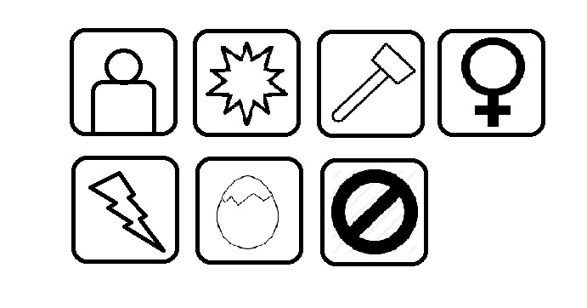

One issue that we’ve flagged with using these icons is that care needs to be taken in where they’re placed – i.e. most should go near the name of the child, but some (e.g. divine father, mother by parthenogenesis belong with the parent (or perhaps on the line that connects parent to child).